**Project Design Phase-II**

**Data Flow Diagram & User Stories**

|  |  |
| --- | --- |
| Date | 29 – June-2025 |
| Team ID | LTVIP2025TMID30749 |
| Project Name | HealthAI: Intelligent Healthcare Assistant Using IBM Granite |
| Maximum Marks | 4 Marks |

**Data Flow Diagrams:**

A **Data Flow Diagram (DFD)** is a structured graphical representation that illustrates how data moves through a system. It captures the flow of information from input to output, highlighting how data is processed, where it is stored, and how external entities interact with the system.

**1. Submit Input**

* **Input: Symptom text, health query, or vital signs**
* **To Process: Handle User Request**
* **Data Flow: Input request →** Health question or symptom data

**2. Handle User Request**

* **Sends:**• Query → IBM Granite Model (via Prompting Engine)  
  • Symptoms → Disease Predictor  
  • Condition → Treatment Generator  
  • Vitals → Health Analytics Module  
  Collects: Patient profile, session context, and selected action
* **Collects user name, uploaded document, and selected action**

**3. Process Request**

Example: DFD Level 0 (Industry Standard)

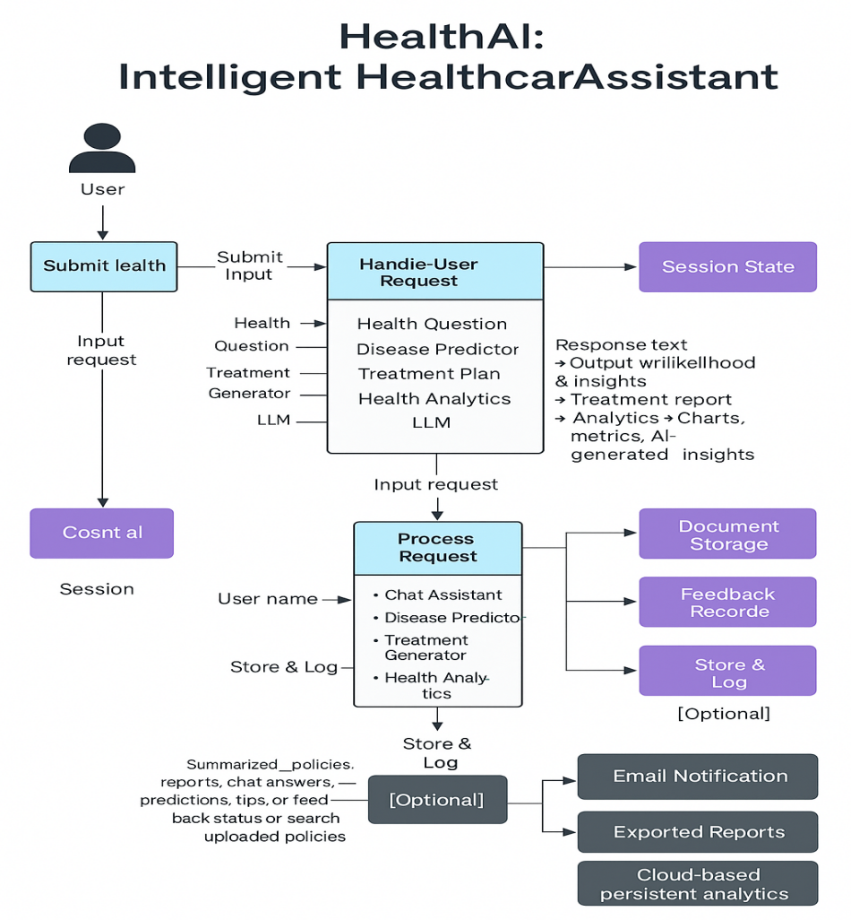

**User Stories**

| **User Type** | **Functional Requirement (Epic)** | **User Story No.** | **User Story / Task** | **Acceptance Criteria** | **Priority** | **Release** |
| --- | --- | --- | --- | --- | --- | --- |
| Patient/User | Ask health questions | USN-1 | As a patient, I can ask a health question in chat format | I receive clear and helpful responses powered by AI | High | Sprint-1 |
| Patient/User | Predict disease | USN-2 | As a user, I can enter symptoms and get possible conditions | I see a list of predicted diseases with likelihoods and next steps | High | Sprint-1 |
| Patient/User | Get treatment recommendations | USN-3 | As a patient, I can enter a condition to receive treatment suggestions | I get personalized plans including medication, lifestyle tips | High | Sprint-1 |
| Patient/User | Visualize health analytics | USN-4 | As a user, I can view trends of my vitals like BP, HR, sugar | I see charts and AI-based insights based on health metrics | Medium | Sprint-2 |
| Patient/User | Edit Profile | USN-5 | As a patient, I can update my profile details | My data is saved and used for personalization | Medium | Sprint-2 |
| Admin/Developer | API Key Security | USN-6 | As a developer, I can secure API credentials via environment files | My credentials are not exposed in source code | High | Sprint-2 |
| Admin/Developer | Prompt Strategy | USN-7 | As a developer, I can define prompting logic for the LLM | Prompts produce consistent and medically relevant results | High | Sprint-2 |
| Patient/User | Use HealthAI without login | USN-8 | As a casual user, I can try HealthAI anonymously with limited features | I can test core functions without sign-in | Low | Sprint-3 |
| Admin | Deploy App | USN-9 | As an admin, I can deploy HealthAI on a secure platform | Users can access the app from a shared link | High | Sprint-3 |